Critical Days of Summer 2013
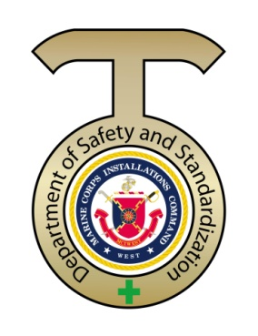

Bicycle Safety

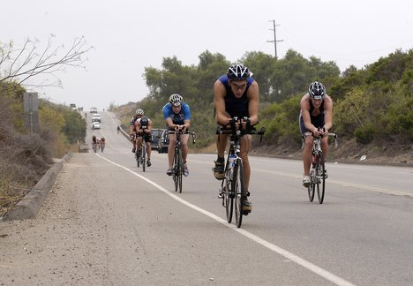

Important! Like all activities, riding a bicycle anywhere involves some risk – and every bicyclist decides how much risk is acceptable. The risks you face when riding on the road with other traffic depend on many factors and how they affect one another, including laws, roadway and traffic signal design, roadway conditions, time of day and weather, riding skill, and common sense. While you may not be able to avoid all risks, you’ll ride more safely and confidently when you understand the risk factors and master the skills that can help reduce them.

As the weather warms up, biking to school, work, or just for fun becomes a lot more appealing and common. With this fun warm-weather activity come some risks: two percent of all traffic fatalities in 2010 were attributed to pedal cyclist accidents according to the National Highway Traffic Safety Administration (NHTSA). It's important to understand and observe the rules of the road, both as a bicyclist and a driver, to keep the roads safe for everyone.
To get ready for bike season; Follow the four basic safety tips on the link below.

http://www.dmv.ca.gov/pubs/brochures/fast_facts/ffdl37.htm
Download the PDF brochures for handout

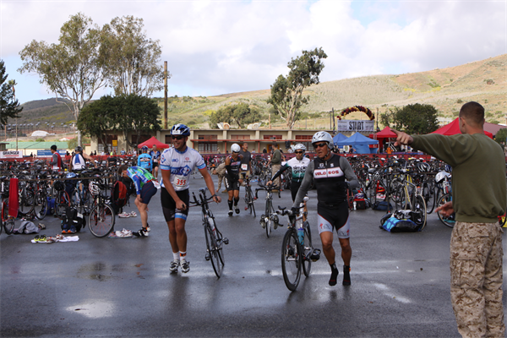

A Safety Survey conducted in the Marine Corps reported that bicycle collisions (with pedestrians or vehicles) are the number one concern. Bicycles are a convenient and popular mode of transportation for people all over the world. We all have our reasons for riding, whether for fitness, work, recreation, or the environment (by taking internal combustion engines off the road). The use of bicycles in cities or on military bases is a great alternative to walking or being stuck in traffic, plus it reduces the costs associated with automobiles.

Bicycle safety includes two main factors. The first is to know how to ride in a given situation. Following the rules of the road and understanding how to navigate some of the hazardous situations identified in this issue will help minimize your chances of a mishap. The second part of safe riding is the ability to see and be seen. Reflective gear, lights, and markers allow other drivers and pedestrians to see you and take appropriate actions so you both can travel safely.

You may think you know how to ride, but that does not mean you do not need reflective equipment. Conversely, wearing reflective equipment does not mean you do not need to know how to ride safely. Either situation can result in serious consequences. Knowing how to ride safely and wearing reflective equipment provides the best combination of safety factors.

We encourage you to review the “Marine Corps Traffic Safety Program”, (MCO 5100.19F), (MCO 5100.30B) Off Duty Recreation Order and MCO 6200.1E W chg/1 Heat Injury Prevention.

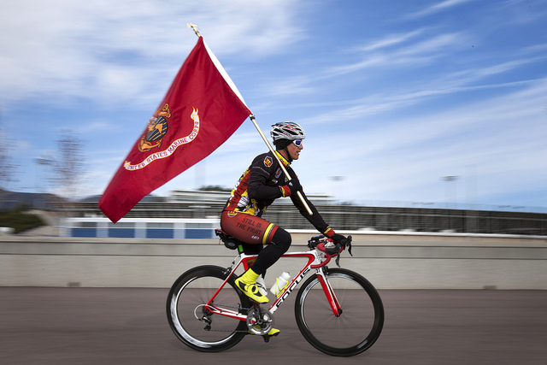

Click on these links for more tips.
http://www.nhtsa.gov/Bicycles
http://www.safetycenter.navy.mil/
https://www.dmv.ca.gov/coi/bicycle/bicycle.htm

MIXED BAG INFO
http://www.public.navy.mil/navsafecen/Documents/media/decisions/spring-summer2013/summersafetyguide.pdf

http://www.public.navy.mil/navsafecen/Pages/media/decisions/spring-summer2013/toc.aspx
(Must read; Takeaway: Power Lines, Off Duty_See, What Happened Was ... and Listening devices//bicycle PPE)

