CSI Express

(Common Sense Impediments)
September 14, 2012 | Volume 1, Number 1
“Don’t put your kids at risk by what you think you know about car seats.  Find out the facts.”  MCIW-MCB SAFETY CENTER  BOX 555031  BLDG 16142  Safety Hotline  (760) 763- SAFE  We’re on the Web!  Safety SharePoint |  | 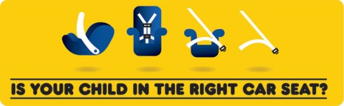  California Law Effective January 1, 2012.  http://www.chp.ca.gov/community/safeseat.html  Children under the age of 8 must be secured in a car seat or booster in the back seat. Children who under the age of 8 who are 4' 9" or taller may be secured by a safety belt in the back seat  MCO 5100.19F – Traffic Safety Order (DRIVESAFE)  Children under the age of 8 years old shall use a serviceable child safety seat appropriate for age and weight of the child in the proper manner, as approved by the DOT, while riding in a motor vehicle on any Marine Corps installation.  Child Car Seat Safety  http://www.nhtsa.gov/Safety/CPS  Car crashes are the number one killer of children 1 to 12 years old in the United States. The best way to protect them in the car is to put them in the right seat, at the right time, and use it the right way.  There are so many car seat types and models, how do you know which one is right for your child? The right car seat or booster fits your child and your car, and is one you will use correctly every time you travel. Not only will your child ride as safely as possible, you will be establishing the foundation for a lifelong habit of seat belt use every time your child travels.  Let us help you make better-informed choices when choosing and using a car seat.  Car Seat Inspection Locator  http://www.nhtsa.gov/cps/cpsfitting/index.cfm  Find a child car seat inspection station nearest you. Certified technicians will inspect your child car seat, in most cases, free of charge - and show you how to correctly install and use it.  For more information  If you have other questions related to car seats or traffic safety, please contact the MCIW-MCB Traffic Safety Manger at 760-763-5070.

