Critical Days of Summer 2013
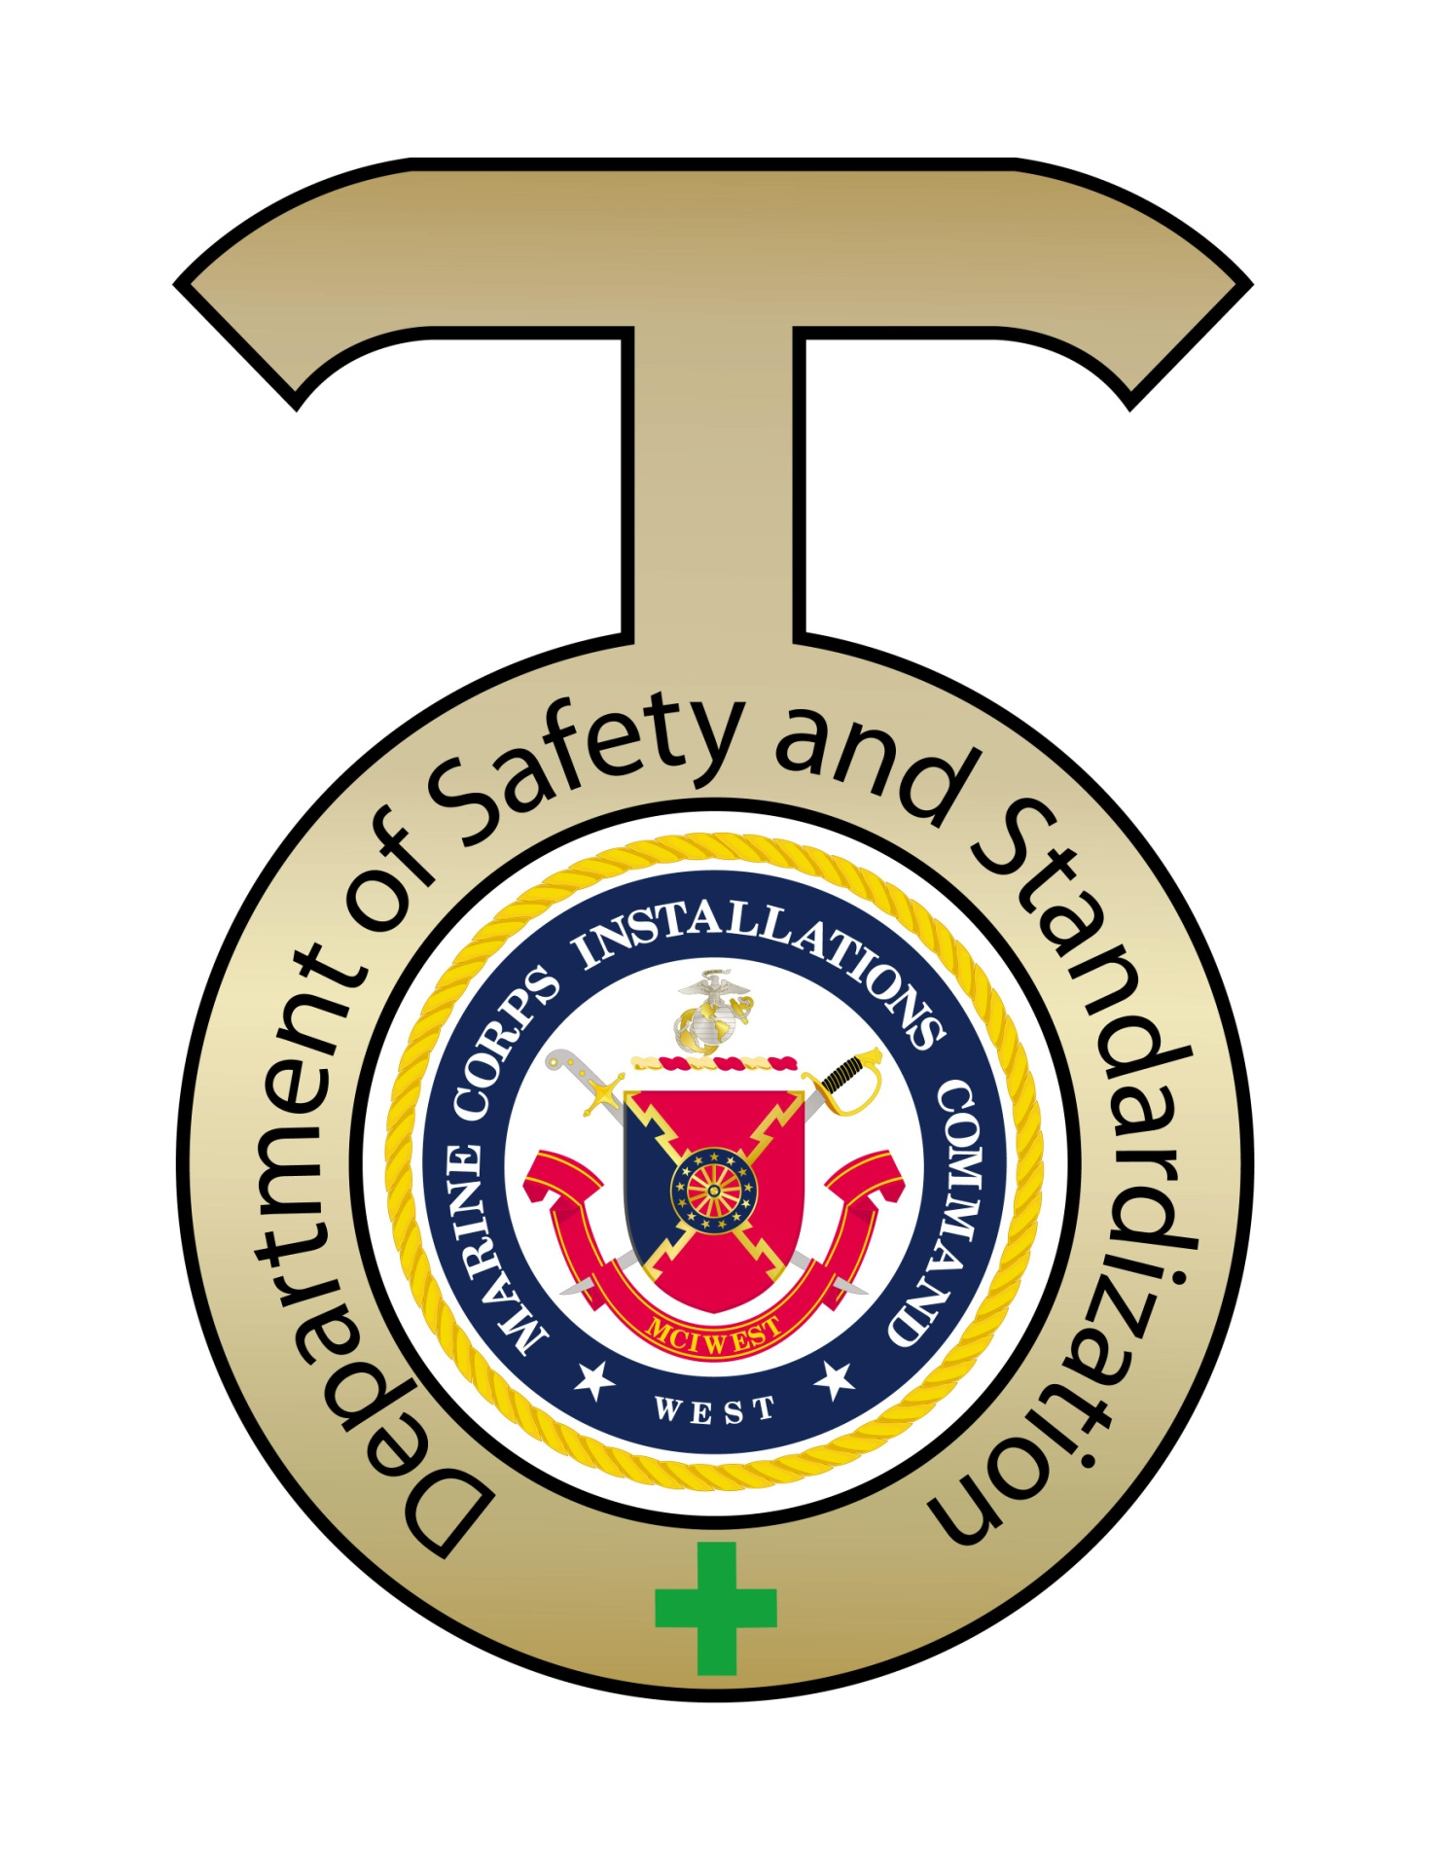
MOTORCYCLE SAFETY
Bottom of Form

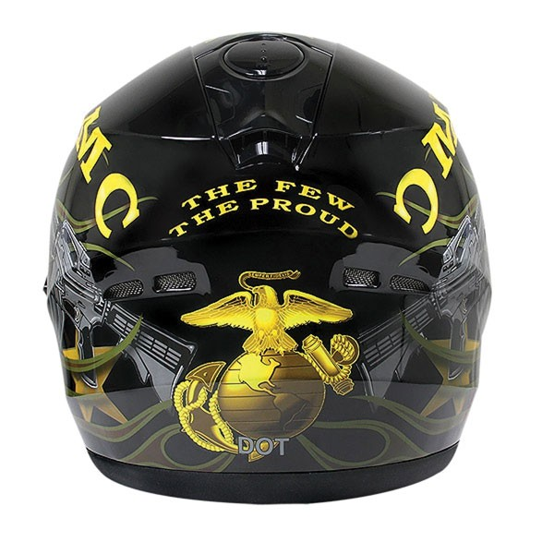

Let’s face it: While motorcycles are cool, they just aren’t as safe as cars. To some people, that’s part of the appeal. Living life on the edge and taking risks can be part of what makes riding a motorcycle rewarding.
Motorcycles can travel as fast as cars do, but lack car safety features most people take for granted. Motorcycles don’t have an exterior frame to absorb crash forces. Instead, the forces of a collision are born directly by the bike and the rider. Motorcycles also don’t have seatbelts, which increases the rider’s risk of being thrown off the bike in an accident. Finally, there’s that little matter of being on two wheels. Motorcycles are simply not as stable as cars.
But, riding a motorcycle doesn’t have to be an exercise in cheating death. Motorcycles may be inherently less safe than cars are, but there are a lot of things motorcyclists and drivers in cars can do to keep everyone safe.
Check the Bike Out:
That's why the Motorcycle Safety Foundation recommends a short pre-ride check of your favorite two-wheeler before every ride. To help you remember what to check, the MSF came up with the acronym T-CLOCS, which stands for Tires, Controls, Lights, Oil, Chassis and Side stand.
These are simple, easy-to-access items that anyone who rides should be able to identify and check. And despite the length of the MSF's list, you can probably check everything in about three minutes. Depending on what you find, that could be the best three minutes you spend all day.
Click on the link for more information
http://www.msf-usa.org/downloads/t-clocsinspectionchecklist.pdf
Take A Class:
It does not matter if riding is something that you have been doing for years or you are a new rider it is important to learn about new laws, brush up on riding skills and this can be done with motorcycle classes that are for every level. These motorcycle classes are provided by the Motorcycle Safety Foundation (MSF).
Click on the link for Marine Corps training guidelines
http://www.defense.gov/home/pdf/0412_militaryrider/DYK_USMC4.pdf

Gear:
We’ve all seen people on motorcycles in shorts and flip flops. Those people are not being safe. Since a motorcycle offers little protection in a crash, what riders wear is part of the crash protection system. Even if you aren’t in a crash with another vehicle on your bike, you could simply lose control and lay the bike down. In that situation, you’ll be sliding along on asphalt. That’s not something you want to do in shorts.
There’s a reason a lot of bikers wear leather: it’s strong enough to protect their skin if they slide along the road surface. Plus, motorcycle riders are exposed to other road hazards, like small rocks, bugs and cigarette butts, that people in cars are protected from. At 60 miles per hour (96.6 kilometers per hour), even a small rock can sting. Leather gear can help protect you.
Ride Within Your Skills:
Riding a motorcycle is a skill, and like all skills, it’s something that you need to develop. While you may be fine to go on an easy cruise around town, it takes time to grow the skills you need to be an expert rider. To stay safe, make sure that you always ride within your skill level. Your friends who have been riding longer may be able to go super fast, weave in and out of traffic, or control their bikes on curvy roads, but that doesn’t mean you should. Take the time to build your skills and only ride in situations where you know your skills are up to the job.
Avoid Distraction:
We all know distracted driving is a bad idea, but its worse when you’re riding a bike. One of the keys to staying safe on a motorcycle is staying hyper-aware of everything that’s going on around you. Remember, motorcycles are tough for drivers to see – especially drivers in large cars or SUVs. You need to see and avoid them, rather than bet on them seeing you. If you’re fiddling with your phone or iPod, you’re reaction time is cut by several precious seconds, putting you at higher risk of a collision
In addition to the risk of distraction, taking your hands off your bike lessens your control more than taking your hands off the wheel of your car. Not only is steering compromised, but so is braking, accelerating and shifting. It’s just a bad idea.
If you’re on a bike, remove all temptation for distraction. Don’t wear headphones, and put your phone where you can’t get to it.

These are just a few of the important tips everyone should utilize when riding and paying attention to while riding a motorcycle. These tips are also designed to help Marines Sailors, DOD Civilians and Dependants understand motorcycle safety.
Once Again, we encourage you to review the “Marine Corps Traffic Safety Program”, (MCO 5100.19F). Collectively we can raise the bar in awareness, reduce risk and maintain a high level of readiness 24/7!

Click on the link for more information
http://www.msf-usa.org/index_new.cfm?spl=2&action=display&pagename=Library

