KEYS TO SUCCESS

1. Mission First – People Always!
- Protect our Reputation.
- Exceed Expectations.
- Promote Mutual Cooperation.
2. Be a Leader
- Strength of Character - Integrity.
- Firm, Fair, Consistent.
- Develop Subordinates through mentoring.
- Embody Core Values (Honor-Courage-Commitment).
3. Be Tactically & Technically Proficient
- Brilliance in Basics; Sustain core competencies.
- Ability to Transition – Normal to Increased Readiness.
- Training equals Proficiency.
4. Accountability
- Your Actions.
- Your Marines.
- Your Equipment.
5. Make Decisions
- The Secret of Courage is Knowledge.
- Be Decisive.
- Exercise Sound Judgment.
6. Create Opportunities for Success
- Be Flexible - Adapt.
- Think Critically - Innovate - Challenge the Norm.
- Allow junior Marines & Supervisors to Lead.
7. Communicate
- Communicate Goals; Facilitate Success.
- Pass the Word.
- Cultivate Team.
- Synchronize Efforts.
8. Safety - In all we do…Work & Play.
9. Family
- Take care of each other…our family.
- Know Your Subordinates Family Issues.
- Involve family in unit activities.
10 Leader Development
- Focus on basic leadership skills.
- Lead – Mentor - Counsel.
- Demonstrate by example.
- Value Subordinate Intellect.

Commander's
Critical Information Requirements

Tier I Immediate Notification (CampPen Specific):

- Terrorist Attack or Attempted Attack.
- Death or serious injury incident (On-Base).
- SecBn death, serious injury, or hospitalization.
- Changes in specific threat or directed FPCON.
- WMD Event [On-base or adjacent].
- Wildfire threatening people or infrastructure.
- Event causing mission-infrastructure degradation.
- Training mishap with injuries or property damage.
- Compromise of classified material or OPSEC.
- Marine Incident generating media interest.
- SecBn Resource dispatched off-base [Non-routine mutual aide].
- Any General-Flag Officer inquiry.

Tier II within 12 hours:
- Non-Tier I Security event; use judgment.
- Off-base LE activity aboard base.
- Significant damage/loss of equipment.
- VIP visit/travel.
- SecBn misconduct e.g., drug/alcohol use, liberty incident, hazing, sexual harassment, or racism.
- Any Red Cross Message.
- O-6 above or O-7 (dependent) incident/traffic cite.
- SecBn Negligent Discharges & GOV vehicle accidents.

Operational & Administrative Readiness
Steering Points

- Promote Military-Civilian Blended Team
- Sustainability: Ops – Trng – Equip Maint
- Accountability.
- Accuracy.
- Timeliness.
- Information Sharing & Synchronization.
Version 1 – Jun 11
COMMAND GUIDANCE

SECURITY BATTALION
AC/S SECURITY & EMERGENCY SERVICES

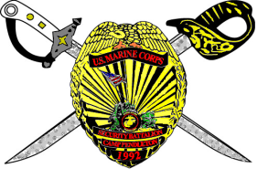

“We Stand the Watch”

Col G. P. Amoroso
Commanding Officer
Security Battalion
Marine Corps Base Pendleton

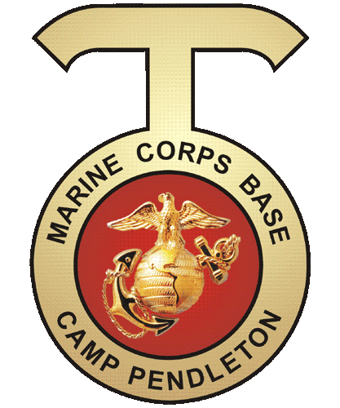

" Some people live an entire lifetime and wonder if they have made a difference in the world. Marines don't have that problem."
Ronald Reagan
MISSION:

“We respond to today’s Crisis – With Today’s Force – Today!” - General James F. Amos CMC.

The Marine Corps is organized, trained, and equipped to operate at and from the sea as part of the naval team to “engage, respond, and project.” The Marine Corps possess the ability to:
- Engage with a wide set of partners in order to build capability, forge solid relationships across cultural barriers, and promote diplomatic access.
- Respond to crises—either natural or man-made.
- Project— either “soft” or “hard” as the situation requires—at and from the sea.
Collectively, these Marine Corps capabilities contribute to preventing conflict, protecting national interests, and assuring overseas access that will enable the United States to prevail in a conflict - MC Op Concepts, Jun 2010.
CMC Priorities:
- Succeed in Afghanistan.
- Rebalance the Marine Corps.
- Markedly Increase Resident Knowledge (PME).
- Keep the Faith with Marines.

MCB: To operate a training base that promotes the combat readiness of the operating force and the mission of other tenant commands by providing training opportunities, facilities, services and support responsive to the needs of Marines, Sailors, their families and civilian employees.

SecBn: Protect life and property, enforce laws and regulations, preserve the good order and discipline, and provide for the confinement and correctional treatment of U.S. military prisoners incarcerated at the base brig.

INTENT:

I have three fundamental principles to guide you:

Mission accomplishment through Positive Leadership. We are a 24/7 organization comprised of a blend of talented Marines and civilian professionals. Our daily duties are inherently dangerous requiring each of us to remain focused on the task at hand and watchful of each other. Fiscal constraints and a wide variety of potential threats create operational and organizational challenges. We will overcome these challenges through strong leadership and individual & organizational innovation.
Leaders ensure the welfare of your Marines, civilian employees, and their families. Effective small-unit leadership is critical to our decentralized, dynamic mission. A well-led, well-trained, well-informed Marine/employee is a formidable smart-weapon. Personal problems erode personal intensity and degrade unit effectiveness. Know your people and their problems. Be proactive; talk with them daily. Listen to what they say; learn what motivates them; enable them for success.
Promote and foster a positive relationship with our military and civilian community. Those we protect and serve are our brothers in arms, friends, and families. I charge each of you to continually seek ways to improve the quality of our services. Equally important, each of you is the face of this Battalion; every positive interaction strengthens the bonds of trust and mutual cooperation. Effective communication, personal initiative, and creative thinking are desired qualities.
1st Line Marine & Civilian Supervisors: You are the focus of effort for SecBn mission success. You are the critical link between individual and leadership. I am committed to you and ways to enhance your performance. Understand, I hold you accountable for all that happens or fails to happen. Multi-dimensional, proactive leadership; personal integrity and fortitude; attention to detail; and continuous innovation are desired qualities. You must have the mental toughness and personal fortitude to exercise good judgment in the absence of supervision.
PHILOSOPHY:

Things I value:

Personal Integrity – Do the right thing!
- Decisive Leadership – Positive Mentorship.
- Sound Judgment.
- Taking care of each other.
- Innovation – Process improvement.
- Exceeding expectations.
Our reputation - Set the example.
Treating others with respect and dignity.
Anticipating requirements– Proactiveness.
Seeing you succeed & grow personally and professionally.
Your opinion.
Fostering positive relations.
Connecting with our Community.
Your dedication – You have mine!
ORM & Safety – On & Off duty.

Things I won't tolerate

People who lie, cheat or steal.
Disregard for Policy.
Drug Use & Alcohol Abuse.
Hazing or maltreatment.
Sexual harassment or misconduct.
Abuse of Power.
Failure to follow orders.
Insubordination.
Mediocrity – Laziness – Selfishness.

