**Critical Days of Summer 2013**

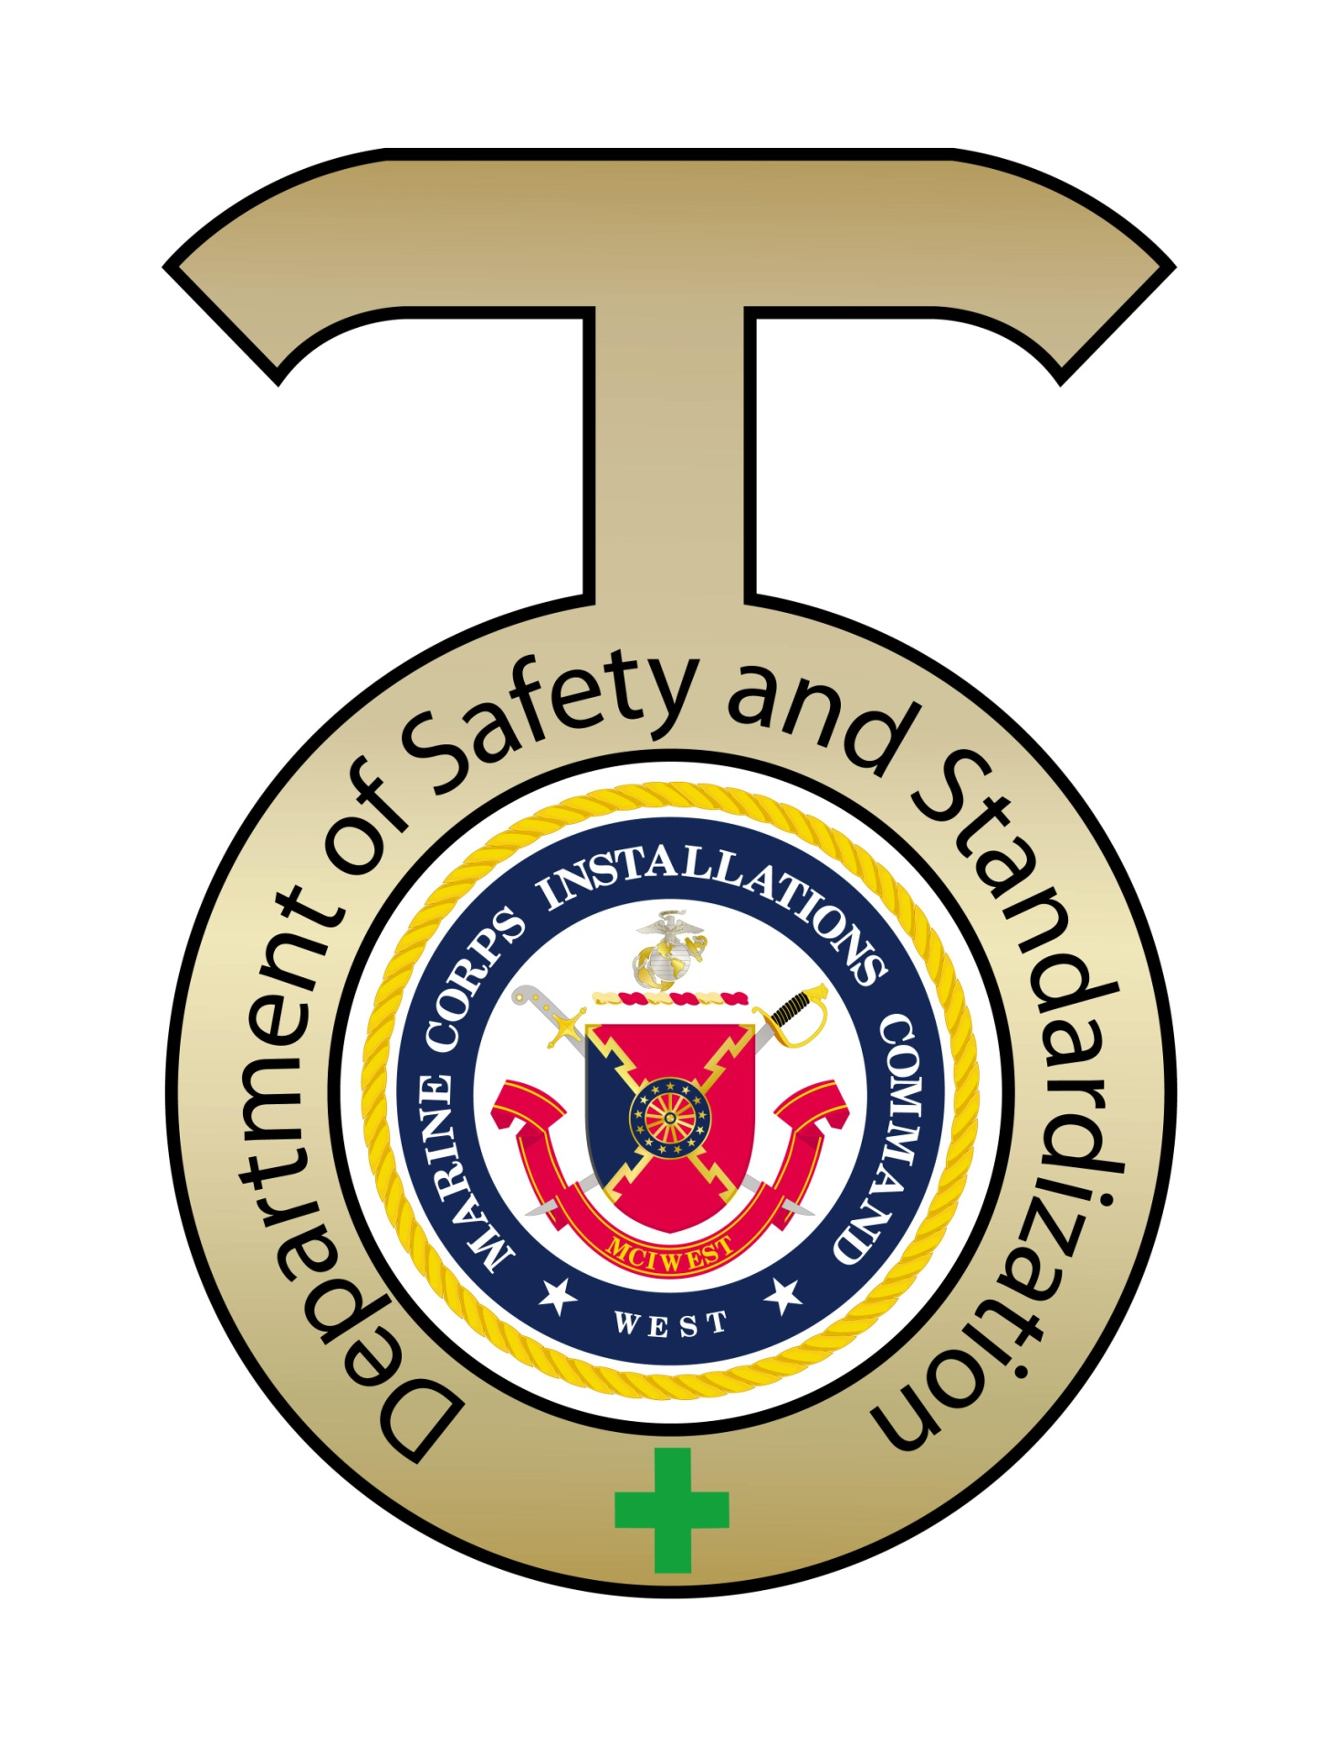

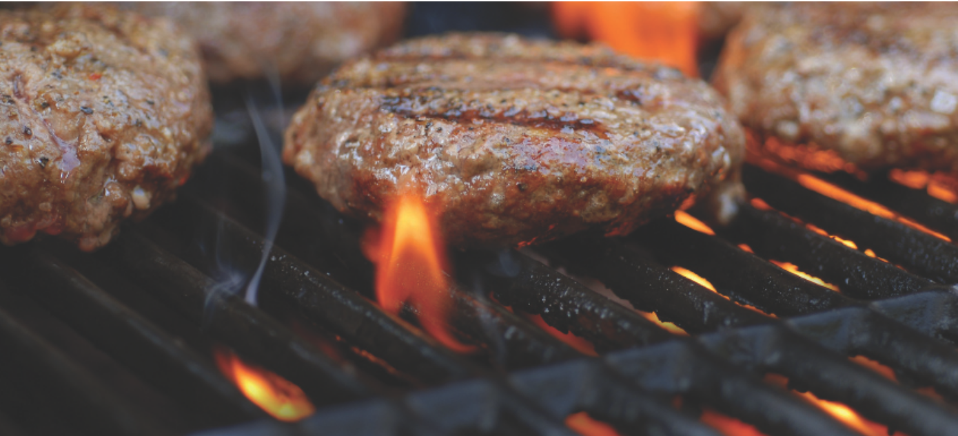

SAFETY TIPS

* Propane and charcoal BBQ grills should only be used outdoors.
* The grill should be placed well away from the home, deck railings and out from under eaves and overhanging branches.
* Keep children and pets away from the grill area.
* Keep your grill clean by removing grease or fat buildup from the grills and in trays below the grill.
* Never leave your grill unattended.

CHARCOAL GRILLS

There are several ways to get the charcoal ready to use.

* Charcoal chimney starters allow you to start the charcoal using newspaper as a fuel.
* If you use a starter fluid, use only charcoal starter fluid. Never add charcoal fluid or any other flammable liquids to the fire.
* Keep charcoal fluid out of the reach of children and away from heat sources.
* There are also electric charcoal starters, which do not use fire. Be sure to use an extension cord for outdoor use.
* When you are finished grilling, let the coals completely cool before disposing in a metal container.
* June and July are the peak months for grill fires.

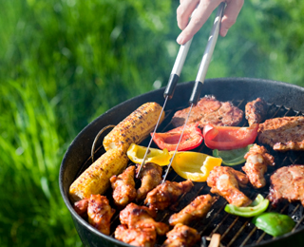

Propane Grills

Check the gas tank hose for leaks before using it for the first time each year. Apply a light soap and water solution to the hose. A propane leak will release bubbles. If your grill has a gas leak, by smell or the soapy bubble test, and there is no flame, turn off the gas tank and grill. If the leak stops, get the grill serviced by a professional before using it again. If the leak does not stop, call the fire department. If you smell gas while cooking, immediately get away from the grill and call the fire department. Do not move the grill.

FACTS

* Fire departments respond to an average of 7,900 home fires involving grills, hibachis or barbecues each year, including 5,000 outside fires and 2,900 structure fires.
* June and July are the peak months for grill fires.
* Thirty-three percent (33%) of home grill structure fires start on an exterior balcony or unenclosed porch.

**Grills are involved in more than 8,000 home structure and outdoor fires per year**

May 25, 2012 – In 2005-2009 U.S. fire departments responded to an average 8,200 home fires involving grills, hibachis, or barbeques per year, including an average of 3,400 structure fires and 4,800 outside fires. These fire incidents have resulted in an annual average of 15 civilian deaths, 120 reported civilian injuries, and $75 million in direct property damage, according to the National Fire Protection Association’s (NFPA) Home Fires involving Cooking Equipment Report.

[**http://www.nfpa.org/assets/files//PDF/IncidentsInvolvingGrills.pdf**](http://www.nfpa.org/assets/files/PDF/IncidentsInvolvingGrills.pdf) (13 pages/read a few)

“As summer approaches, the threat of grilling fires is becoming more prevalent,” said Lorraine Carli, NFPA’s vice president of Communications. “Although grilling fires are more common in warmer months, it is important to remember that grilling fires do occur throughout the entire year and simple steps can be taken to avoid them.”

July is the peak month for grills fires, accounting for 18 percent of all home fires involving grills, including both structure and outside fires. June and May follow closely with 14 percent and 13 percent respectively. The smallest share of fires occurred throughout the winter months, grill fires do occur throughout the year.

The NPD group reports that more people are grilling all year round, showing that nearly one-third (38 percent) of American households had at least one meal cooked on an outdoor grill in an average two-week period during the year. Even in the winter months of December, January and February, one-quarter (27 percent) had eaten at least one grilled item in a 14-day period.

For more information visit:

[www.nfpa.org/grilling](http://www.nfpa.org/itemDetail.asp?categoryID=298&itemID=18346)

[www.nfpa.org/education](http://www.nfpa.org/categoryList.asp?categoryID=1491)

“Grilling during the warmer months, or throughout the year, is a welcome sight at cookouts,” Carli said. “But fire anywhere else can make your kick-off barbeque memorable for all the wrong reasons. By reviewing grilling safety tips this season you can prevent home grilling fires not only as the weather gets nicer, but also all year long.”

Other key findings in this report include:

• Five out of every six grills involved in home fires (84 percent) were fueled by gas while 13 percent used charcoal or other solid fuel.

• More than one quarter (29 percent) of the home structure fires involving grills started on a courtyard, terrace or patio.

• In 2009, 17,700 patients went to the emergency room because of injuries involving grills.

• Children under the age of five account for almost one-quarter (22 percent) of all thermal grill burns.

NFPA offers the following safety tips:

• Propane and charcoal BBQ grills should only be used outdoors.

• The grill should be placed well away from the home, deck railings and out from under eaves and overhanging branches.

• Keep children and pets away from the grilling area.

• Keep your grill clean by removing grease or fat buildup from the grills and in trays below the grill.

• Never leave your grill unattended.