Critical Days of Summer 2013
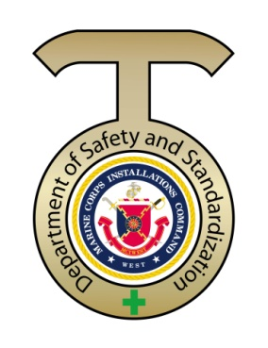
Heat Injury Safety

Bottom of Form
Summer heat waves can be dangerous

Older people are at the highest risk. People normally cool their bodies by sweating, but under some conditions, sweating isn't enough. Very high body temperatures may damage the brain or other vital organs. Some conditions that can limit the ability to regulate temperature include old age, obesity, fever, dehydration, heart disease, poor circulation, sunburn, and drug and alcohol use. Summertime activity, whether on the playing field or the construction site, must be done in a way to aid the body's cooling mechanisms and prevent heat-related illness.

Click on for heat awareness news clip “2012”
http://www.calema.ca.gov/NewsandMedia/Pages/Cal%20EMA%20Live%20Archive/Heat-Awarenes-and-Safety.aspx

Heat safety tips from CDC (Centers for Disease Control and Prevention)
“Keep Cool in Hot Weather”

http://www.cdc.gov/Features/ExtremeHeat/

Protecting Against Heat Injuries

Drink Plenty of Fluid - Increase your fluid intake regardless of your activity level. During heavy exercise in hot weather, drink 2-4 glasses (16-32 ounces) of cool fluids each hour. Avoid very cold beverages to prevent stomach cramps or drinks containing alcohol, which will actually cause you to lose more fluid.
Replace Salt and Minerals - Heavy sweating removes salt and minerals from the body, which are necessary for your body and must be replaced. The best way to replace salt and minerals is to drink fruit juice or a sports beverage during exercise or any work in the heat.
Wear Appropriate Clothing and Sunscreen - Wear as little clothing as possible when you are at home. Choose lightweight, light-colored, loose-fitting clothing. In the hot sun, a wide-brimmed hat will keep the head cool. A variety of sunscreens are available to reduce the risk of sunburn. Check the sun protection factor (SPF) number on the label of the sunscreen container. Select SPF 15 or higher and follow package directions.
Slow down- Strenuous activities should be reduced, eliminated, or rescheduled to the coolest time of the day. Individuals at risk should stay in the coolest available place, not necessarily indoors.
Pace Yourself - If you are unaccustomed to working or exercising in hot weather, start slowly and pick up the pace gradually. Stop all activity, get into a cool or shady area, and rest, especially if you become lightheaded, confused, weak, or feel faint.
Stay Cool Indoors - The most efficient way to beat the heat is to stay in an air conditioned area. Consider a visit to a shopping mall or public library for a few hours. A cool shower or bath is a more effective way to cool off.
Schedule Outdoor Activities Carefully - If you must be out in the heat, plan your activities so that you are outdoors either before noon or in the evening
Use Common Sense - Avoid hot foods and heavy meals; they add heat to your body. Do not leave infants, children, or pets in a parked car. Bring your pets indoors with you to protect them. Dress infants and young children in cool, loose clothing and shade their heads and faces with hats or an umbrella. Limit sun exposure during the midday hours and in places of potential severe exposure, such as beaches. Ensure that infants and children drink adequate amounts of liquids. Give your outdoor animals plenty of fresh water, leave the water in a shady area, and consider wetting the animal down.
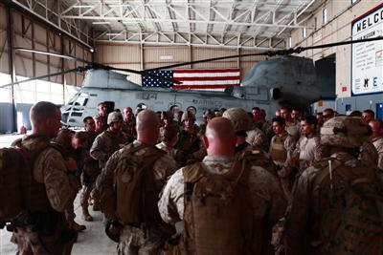

- “Drink more water!" If you have spent any time in the Marine Corps you have likely heard this a time or two, and for good reason. The National Oceanic and Atmospheric Administration statistics indicate the United States had 400 heat fatalities in 2011, making heat the number one killer among weather related deaths.
- Over a 10-year span, heat was a close second to hurricanes, and floods placed third. The Marine Corps has taken a stand against this silent killer and has programs in place to protect Marines.
- The Marine Corps Heat Injury Prevention Program, Marine Corps Order 6200.1E, provides a simple understanding of heat injuries, a guide to the heat condition flag warning system, guidelines for fluid replacement in warm weather and more.
- Bottom line, summer temperatures have arrived and the message from Marine Leaders and health officials is clear. — "To avoid injury, hydrate, hydrate, hydrate and ensure Marines around you are doing the same."

- Click on the link for more tips.
http://www.safetycenter.navy.mil/

Heat Index and Physical Exercise (Marine Corps)
Heat related illness includes: heat rash, cramps, exhaustion and stroke. These illnesses are a real danger to people not accustomed to the stress of hot weather exercise.
The Wet-Bulb Globe Temperature Index (WBGTI) takes into account four variables: air temperature, humidity, radiant heat and air movement. This reading gives a more accurate measurement of heat stress than any one reading alone.

Heat Index and Physical Exercise Chart
WBGT Index (F) | Flag Color | Heat Condition Flag  Warning System  MCO 6200.1D
80-84.9 | Green | Heavy exercises, for unacclimatized personnel will be conducted with caution and under constant supervision.
85-87.9 | Yellow | Strenuous exercises, such as marching at standard cadence, will be suspended for unacclimatized troops in their first 2 or 3 weeks. Outdoor classes in the sun are to be avoided.
88-89.9 | Red | All physical training will be halted for those troops who have not become thoroughly acclimatized by at least 12 weeks of living and working in the area. Those troops who are thoroughly acclimatized may carry on limited activity not to exceed 6 hours per day.
90 and Above | Black | All strenuous non-essential outdoor physical activity will be halted for all units. Essential activities are defined as those activities associated with scheduled exercises or other major training evolutions where the disruption would cause undue burden on personnel or resources, be excessively expensive, or significantly reduce a unit's combat readiness. Essential outdoor physical activity will be conducted at a level that is commensurate with personnel acclimatization as determined by the unit's commanding officer in coordination with the unit's medical officer or medical personnel. All efforts should be made to reschedule activities during cooler periods of the day.

Wearing of body armor or NBC warfare protective uniforms in effect adds 10 degrees F to the measured WBGTI. Heat conditions will be adjusted appropriately.

Heat Index and Physical Exercise (Navy)
Heat related illness includes: heat rash, cramps, exhaustion and stroke. These illnesses are a real danger to people not accustomed to the stress of hot weather exercise.

The Wet-Bulb Globe Temperature Index (WBGTI) takes into account four variables: air temperature, humidity, radiant heat and air movement. This reading gives a more accurate measurement of heat stress than any one reading alone.

Contact your local Environmental Prevention Medicine Unit (EPMU) for PT related weather readings.

Heat Index and Physical Exercise Chart
WBGT Index (F) | Flag Color | Intensity of Physical Exercise  NAVMED P-5010 CH 9
Less than 80 | White | Extremely intense physical exertion may precipitate heat exhaustion or heat stroke, therefore, caution must be taken.
80-84.9 | Green | Discretion is required in planning heavy exercise for unacclimatized personnel. This is a marginal heat stress limit for all personnel.
85-87.9 | Yellow(Amber) | Strenuous exercise and activity must be curtailed for new and unacclimatized personnel during the first 3 weeks of heat exposure. Outdoor classes in the sun must be avoided when the WBGT index exceeds 85.
88-89.9 | Red | Strenuous exercise must be curtailed for all personnel with less than 12 weeks training in hot weather.
90 or Above | Black | Physical training and strenuous exercise must be suspended for all personnel. (excludes operational commitment not for training purposes).

Wearing body armor or NBC protective uniforms adds approximately 10 points to the measured WBGTI. Limits of exposure should be adjusted accordingly.

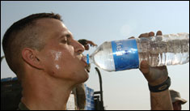

MCIWEST-MCB CAMPENO 6200.4 (Heat Injury Prevention) provided amplifying guidance to heat injury prevent aboard MCB Camp Pendleton.

