5 Things You Should Know About Marine Corps Energy
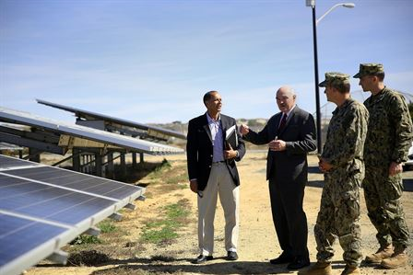
Photo: http://www.marines.mil/Photos.aspx?igphoto=2000783216
- Energy Supply Lines Put Marines at Risk.
Energy is one of the Marine Corps’ most vulnerable commodities. When Marines and Sailors transport fuel, they are vulnerable to attack. Take care of your fellow Marines – use only what you need.
- Energy is Mission Critical.
From training and support on base to transport and mission effectiveness on the battlefield, energy supports our mission. Battlefield conditions, natural disasters, and our enemies can limit access to critical energy supplies. Remember: The less energy-dependent Marines are, the more agile and lethal our Corps will be.
- Energy is Expensive.
The Marine Corps spent $262M on installation energy alone in FY13 – that doesn’t account for the fuel required for training efforts or deployed environments. Reducing installation energy use by 10 percent could save the Marine Corps $26M. That is almost the same amount of money it takes to fully execute five Integrated Training Exercises (ITXs), the crux of pre-deployment training. In a time when budgets continue to contract, using only what you need allows Marines to train longer, go further, and be more effective in executing our missions.
- Small Steps Can Have Big Impacts.
Small changes in energy use can yield substantial results. Heating and cooling accounts for as much as one half of home energy use. Setting a thermostat back 10-15 degrees for 8 hours a day can save 15 percent of annual heating and cooling costs. Turning off lights at night, when leaving a room, or using natural lighting can also drive big savings.
- October is Energy Action Month!
Energy Action Month is a federal program that encourages energy and water savings in federal facilities. Marines are encouraged to develop energy and water saving behaviors, and talk to their leadership, fellow Marines, and Energy Managers about energy use in their unit.
5 Things You Should Know About the Unit Energy Manager (UEM) Program

Photo: https://www.flickr.com/photos/marine_corps/13716104355/
- Fulfilling the Commandant’s Vision.
The Commandant’s vision in the Marine Corps Expeditionary Energy Strategy stated that “tenants and supported commands [will] identify an Energy Manager or representative at the individual unit or tenant level to coordinate unit and tenant involvement and actions as part of the installation’s overall Energy Program.” In 2013, Marine Corps Installations Command (MCICOM) released the Installations Energy Strategy, which titled this program the Unit Energy Manager (UEM) Program and called for the assignment of UEMs.
- UEMs Will Drive the Energy Ethos.
The Marine Corps Energy Ethos is the shared vision that the efficient use of energy resources is a critical component of mission readiness. Marines who adopt the Energy Ethos create energy efficient habits that span from bases to battlefield. UEMs will educate fellow Marines about the many ways to conserve energy and water at work and at home.
- UEMs Will Have a Variety of Responsibilities.
A unit’s UEM will work to increase awareness on energy usage, cost, goals, and objectives; teach Marines specific energy-saving techniques; serve as the point of contact to Installation Energy Managers (IEMs), Marines, and operational leadership on unit energy matters; undergo energy trainings; identify potential energy saving opportunities; and generate work orders for facility energy efficiency projects. All of these efforts will enable operational and installation commands to have more visibility into the use of energy resources.
- UEMs are Marines Working to Help the Unit.
UEMs will be appointed by their Unit Commander, and will be an E-4 or above. Ideal UEMs will have an interest in leadership, energy, or logistics and will apply those interests to support their unit’s mission. Marines can come to UEMs to point out leaky doors or windows, report broken or dripping faucets, request more efficient light bulbs, inquire about power strips, ask about energy use metrics, and more. UEMs will be able to work with IEMs, facilities staff, and other parties to respond to Marine inquiries.
- Being a UEM Has Many Benefits.
UEMs will have an opportunity to develop expertise in the growing field of renewable energy; to receive promotion and award opportunities for excellent performance; to increase their knowledge of business, audits, management, communications, and planning; to gain exposure to leaders through reporting of energy data and communications efforts; and to experience being a unit leader, developing vital leadership skills, and gaining credibility.

